Actualize Store Procedure

Actualize modelo

|  |  |
| --- | --- |
|  | Doble click on **edmx** |
|  | Right click on white to update model  Select update from database  Rebuild all |

En IRPAService.cs agregue en DataContract los nuevos campos

[DataContract]

public class ATTSiteSettings

{

[DataMember]

public string Dealer { get; set; }

[DataMember]

public int LogLevel { get; set; }

Check entity container has the new fields in the same order as the S.P.

</EntityContainer>

<ComplexType Name="spGet_ATT_Site_Result">

<Property Type="Int32" Name="LogLevel" Nullable="true" />

<Property Type="String" Name="OPUSURL" Nullable="true" MaxLength="255" />

<Property Type="String" Name="MSCT" Nullable="true" MaxLength="1" />

</ComplexType>

<FunctionImportMapping FunctionImportName="spGet_ATT_Site" FunctionName="RPAModel.Store.spGet_ATT_Site">

<ResultMapping>

<ComplexTypeMapping TypeName="RPAModel.spGet_ATT_Site_Result">

<ScalarProperty Name="LogLevel" ColumnName="LogLevel" />

<ScalarProperty Name="OPUSURL" ColumnName="OPUSURL" />

<ScalarProperty Name="MSCT" ColumnName="MSCT" />

</ComplexTypeMapping>

</ResultMapping>

</FunctionImportMapping>

**Rebuild as Release, todos, como Batch Build**

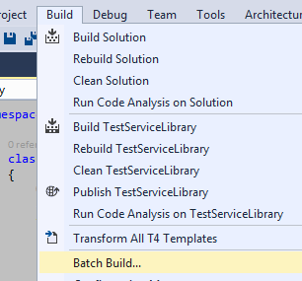

Para probar si todo bien, de primero **Update Service Reference** in test project

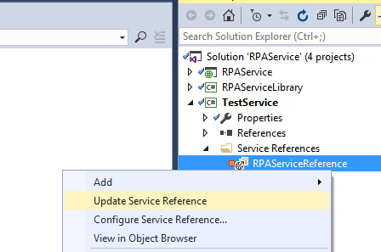

Si todo funciono bien la prueba de Publish

Publish WebService (not the library)

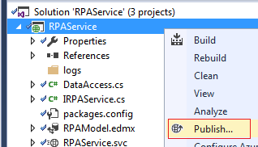

1>Publishing folder /...

1>Publishing folder bin...

1>Web App was published successfully file:///C:/Deploy/RPAService/

1>

========== Build: 0 succeeded, 0 failed, 1 up-to-date, 0 skipped ==========

========== Publish: 1 succeeded, 0 failed, 0 skipped ==========

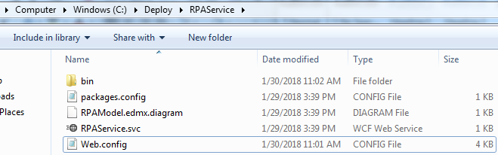

Copy to server orliwv024

Primero a MyDocuments, y luego a E:\WebApps\RPAServiceDev

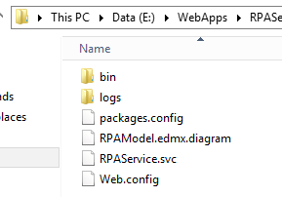

y luego a E:\WebApps\RPAServiceDev

Verifique en web config que esta direccionado a Desarrollo o produccion

Desarrollo : data source=C03DWV010

Produccion : data source=